**SRS**

**(Software Requirements Specification)**

**Introduction**

The manual work makes the process slow and other problems such as inconsistency and ambiguity on operations. In order to avoid this web based placement managed system is proposed, where the student information in the college with regard to placement is managed efficiently. It intends to help fast in fast access procedures in placement related activities and ensures to maintain the details of the student. Students logging should be able to upload their personal and educational information.

**1.1 Purpose**

This Software Requirements Specification provides a description of all the functions and constraints of the Placement Management System, developed for various colleges’ placement cell.

The Placement Management System is for the students and companies which maintains the database for the students where all the students’ records are entered including their academic details and their personal details. It will also manage the data of the Company which would comprise of the profile of the Company, eligibility criteria and the facilities or the package it provides etc.

The System would provide the facility of viewing both the personal and academic information of the student and company; it would also search for eligible students and Company and deal with the insertion and deletion of records.

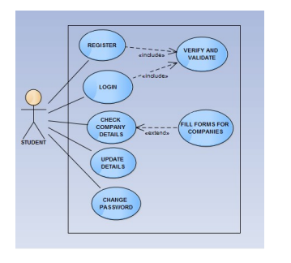

**1.2 SCOPE:**

Our project has a big scope to do. Students can access previous information about placement. We can store information of all students. Various companies can access their information. Notifications are sent to students about the companies.

• Automation of Placement Procedure

• No Need to do Paper Work

• To save the environment by using paper free work

• To increase the accuracy and efficiency of placement procedure

• Management of Student Data

• Analysis of overall Placement

**1.3 Benefits:**

In order to avoid above existing placement problem, we are planning to design a system for online placement, so that placement activities becomes more interactive, automated and effective.

1. Reduce the paper work and create data base of student

2. Save time & work load for TPC.

3. Easy to access. 4. Avoid fake Entry.

5. Only eligible students get chance.

6. Improve accuracy in result.

7. User friendly interface.

**FUNCTIONAL STUDY**

**1.4FUNCTIONAL REQUIREMENT**

**Module:**

• Student

• Admin

• Company

**A. STUDENT MODULE:**

In this module, creation of student input records about academic career from SSLC, HSC and all semester with facilities to modify the records and viewing changed records. The Student views the company details and verifies particular company details and provides valid details for registration.

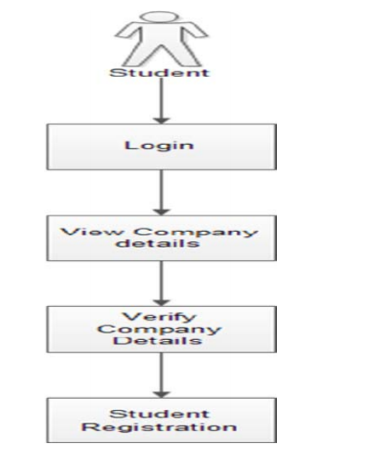

**B. COMPANY MODULE:**

The company enrolls themselves and they register their profile and their will marquee in the main page till their drive and view the student’s details and update their details. Login Company, registration, student’s details view

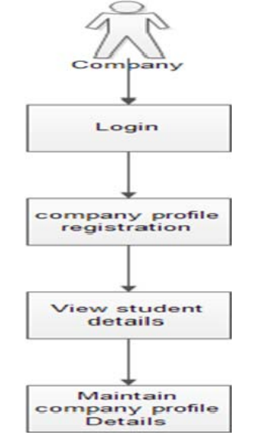

**C. ADMIN MODULE:**

The admin is the placement officer who views the students details and company details and post the selected students list. Sending email to student for complete list of information for particular campus. Indication of hall ticket issued to candidates through mail. Login, View company details, View selected students’ details, Sending mail.

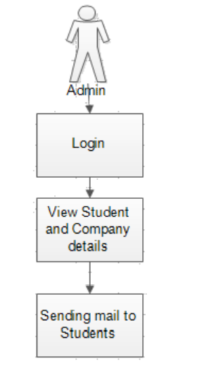

**DESIGN DOCUMENT**

TABLE NAME- STUDENT

PK- User-ID

DESCRIPTION- Student information

|  |  |  |  |  |
| --- | --- | --- | --- | --- |
| Field Name | Data Type | NULL? | KEY | Description |
| Sl_NO | INT | N |  | Serial No |
| Student_ ID | VARCHAR(10) | N | Pk | User Id |
| Student Name | VARCHAR(40) | N |  | Name of User |
| Department_ID | VARCHAR(10) | N |  | Type dept |
| DOB | DATETIME | N |  | Date Of Birth |
| Mobile | VARCHAR(10) | N |  | Mobile number |
| Email | VARCHAR(50) | N |  | User Email |
| Address | VARCHAR(80) | N |  | User Address |
| Grade | VARCHAR(6) | N |  | Grade |

TABLE NAME- COMPANY

PK- User-ID

DESCRIPTION- Company information

|  |  |  |  |  |
| --- | --- | --- | --- | --- |
| Field Name | Data Type | NULL? | KEY | Description |
| Sl_NO | INT | N |  | Serial No |
| Company ID | VARCHAR(10) | N | Pk | User Id |
| Company Name | VARCHAR(40) | N |  | Name of User |
| Department | VARCHAR(10) | N |  | Type dept |
| Website | VARCHAR(255) | N |  | Website |
| Mobile | VARCHAR(10) | N |  | Mobile number |
| Email | VARCHAR(50) | N |  | User Email |
| Address | VARCHAR(80) | N |  | User Address |
| Date created | Date | N |  | date |
| Salary package | INT | N |  | salary |

TABLE NAME- ADMIN LOGIN

PK- USER ID

DESCRIPTION- Admin information

|  |  |  |  |  |
| --- | --- | --- | --- | --- |
| Field Name | Data Type | NULL? | KEY | Description |
| Sl_NO | INT | N |  | Serial No |
| User name | VARCHAR(20) | N | Pk | User name |
| User password | VARCHAR(60) | N |  | User password |
| User registered | date time | N |  | User registered |

**PROGRAM SPECIFICATION**

**ADMIN LOGIN**

|  |  |
| --- | --- |
| **Module** | Admin |
| **Menu Reference** | Login |
| **Dependency on Module** | NA |
| **Inputs** | |
| * User Name * Password | |
| **Validation** | |
| * Username should not blank. * Password should. * Invalid Username or password. * System locked for three wrong password entered. * Password should expire in 60 days * Password has expired, change the password | |
| **Process Logic** | |
|  | |
| **Output** | |
| * Redirect to admin Dashboard | |

COMPANY LOGIN

|  |  |
| --- | --- |
| **Module** | COMPANY |
| **Menu Reference** | Login |
| **Dependency on Module** | NA |
| **Inputs** | |
| * User Name * Password | |
| **Validation** | |
| * Username should not blank. * Password should. * Invalid Username or password. * System locked for three wrong password entered. * Password should expire in 60 days * Password has expired, change the password | |
| **Process Logic** | |
|  | |
| **Output** | |
| * Redirect to company Dashboard | |

**STUDENT LOGIN**

|  |  |
| --- | --- |
| **Module** | STUDENT |
| **Menu Reference** | Login |
| **Dependency on Module** | NA |
| **Inputs** | |
| * User Name * Password | |
| **Validation** | |
| * Username should not blank. * Password should. * Invalid Username or password. * System locked for three wrong password entered. * Password should expire in 60 days * Password has expired, change the password | |
| **Process Logic** | |
|  | |
| **Output** | |
| * Redirect to student Dashboard | |

**User Registration**

|  |  |
| --- | --- |
| **Module** | Student |
| **Menu Reference** |  |
| **Dependency on Module** | Login |
| **Inputs** | |
| * User ID * User Name * Mobile * Email Id * DOB * Dept | |
| **Validation** | |
| * Username should not blank. * All fields are mandatory (*) * Could not save data at this time. * User already exist | |
| **Process Logic** | |
|  | |
| **Output** | |
| * Data save Successfully and Redirect to student Home Page | |

**Company Registration**

|  |  |
| --- | --- |
| **Module** | Company |
| **Menu Reference** |  |
| **Dependency on Module** | Login |
| **Inputs** | |
| * User ID * User Name * Mobile * Email Id * DOB | |
| **Validation** | |
| * Username should not blank. * All fields are mandatory (*) * Could not save data at this time. * User already exist | |
| **Process Logic** | |
|  | |
| **Output** | |
| * Data save Successfully and Redirect to company Home Page | |

**Admin Registration**

|  |  |
| --- | --- |
| **Module** | Admin |
| **Menu Reference** |  |
| **Dependency on Module** | Login |
| **Inputs** | |
| * User ID * User Name * Mobile * Email Id * DOB * Post | |
| **Validation** | |
| * Username should not blank. * All fields are mandatory (*) * Could not save data at this time. * User already exist | |
| **Process Logic** | |
|  | |
| **Output** | |
| * Data save Successfully and Redirect to Admin Home Page | |